**Module 1**

Scientific computing libraries in Python  
-Scientific computing : Pandas (data structure, tools), NumPy (arrays, matrices), SciPy (advanced math)  
-Visualization : Matplotlib (plots, graphs) , Seaborn (heat maps, time series, violin plots)  
-Algorithmic : Scikit-learn (Machine learning, regression, classification…), Statsmodel (Explore data, estimate stat model, stat test)

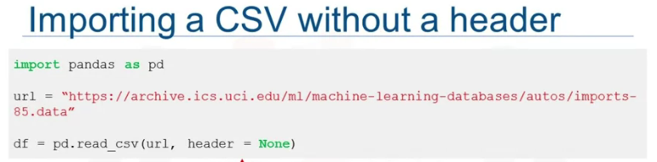Importing and Exporting Data in Python  
Process of loading and reading data into python from various resources  
  
Properties  
- Format (csv,json,xlsx,hdf)  
- File path (computer, internet)



